**Section 22 Deploying an Angular App**

**Section 22: Lecture 290//Module Introduction**

1. We will deploy the app as Amazon web services as free, that will be displayed in next lectures

**Section 22: Lecture 291//Deployment preparations and Important steps**

1. Steps and things to keep in mind while deploying an Angular App:
2. first, we must build our app for production – which means we should minify the code and we should consider ahead of time Compilation.
3. If we are using Angular CLI – run – **ngbuild –prod –aot** //this will give us all of that OOB
4. Base element in the index.html file //that is something we have not looked at yet – should be set correctly.
5. Now, by default if we are serving out app from ourdomain.com/ // then it will be set correctly
6. But if our angular app doesn’t run on our root domain, but, instead on a nested path like /my-app/ //in this we need to adjust the base element to /myApp/ //this is required by angular router to work correctly.
7. Also, we need to make sure that our server returns index.html file always.
8. That means if we encounter a 404 error on the server i.e. page not found.
9. In this case also route is processed first.
10. The server will try to find the recipe folder or route, now, the route is internal part of the Angular and not the part of server - in this case the server will through 404 error.
11. We would need to configure as always return the angular app in case of unfound route, because then angular gets a chance of taking over. This will atleast make chance of reaching that app. In this scenario in case of any error we can return error from our app.
12. 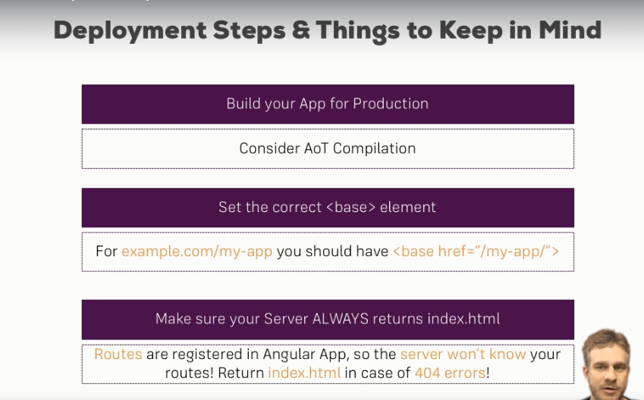

**Section 22: Lecture 292//Example: Deploying to AWS S3**

1. We can create one amazon web services account. They have free tier - we can google it what are the limits of the AWS free tier.
2. 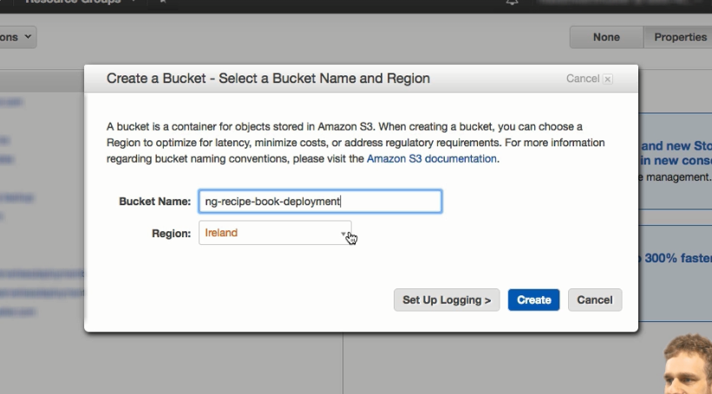
3. 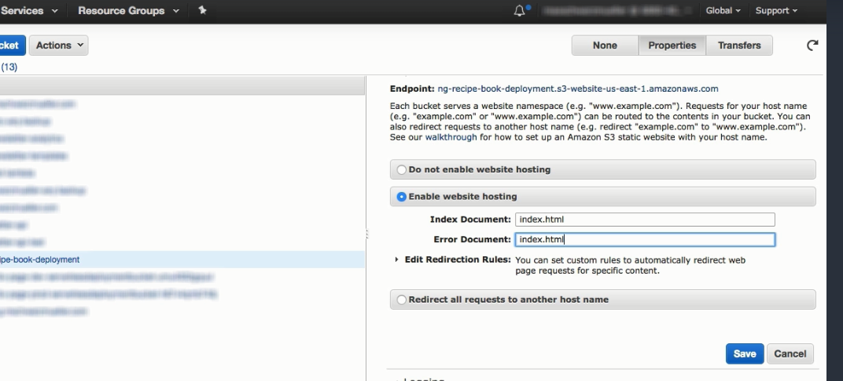
4. 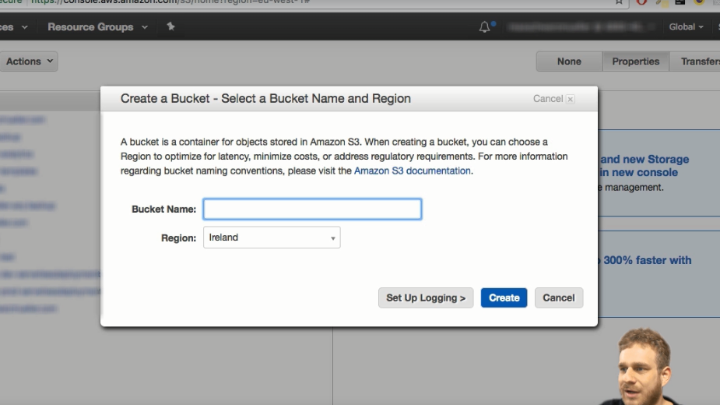
5. Before uploading the app run; ng build –prod –aot
6. It will be created in a dist folder // dist means - distribution
7. 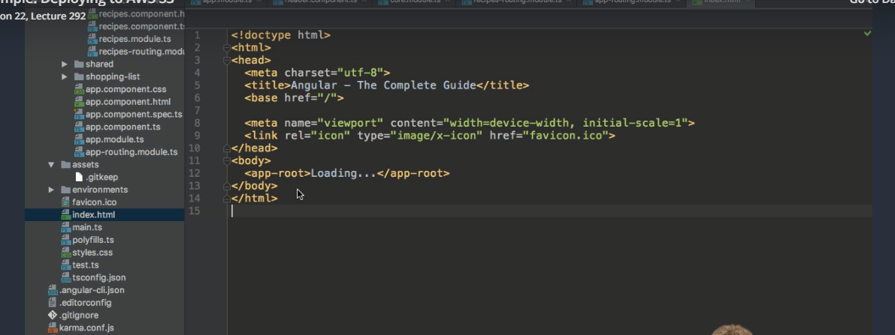
8. To set path for my app we can run below command:

ng build –prod –aot –base-href

1. We need to upload all the files that are present in the dist folder.

=======================END OF SECTION =======================================